Dear residents,
We are only completing emergency maintenance in apartments at this time. This is for the safety of residents and staff.
Emergency maintenance includes:
- Sparks or fires (call 911 first, then call for maintenance)
- Water leaks or gas leaks
- Clogged toilet or drain that a plunger can't fix (resident charges will apply)
- No hot water
- No heat
- Exposure to the elements (broken window, hole in roof, door that won't lock, etc.)
- Lock-outs (resident charges will apply)
- Stove or refrigerator not working
- Electricity out
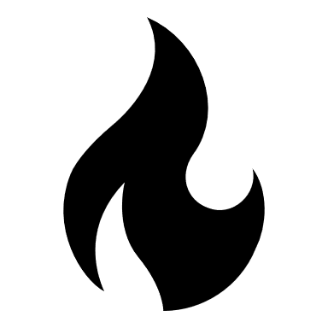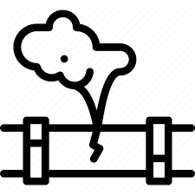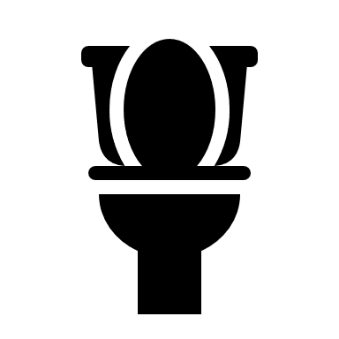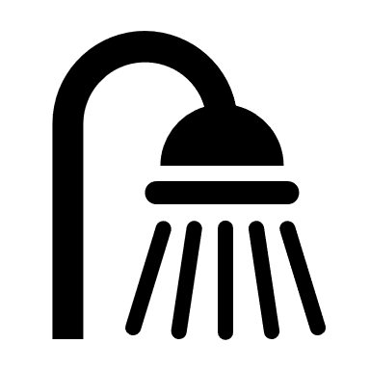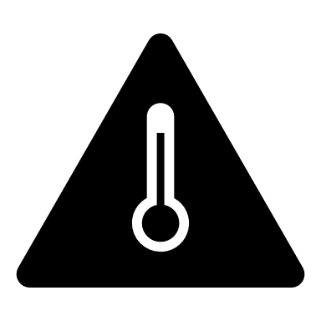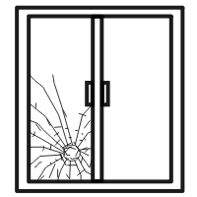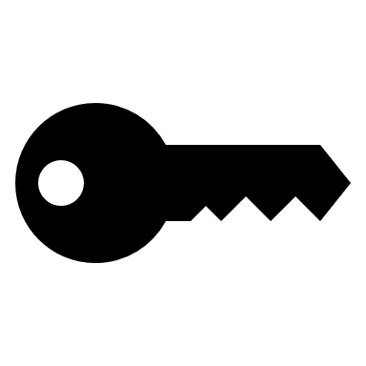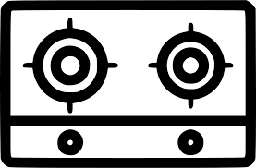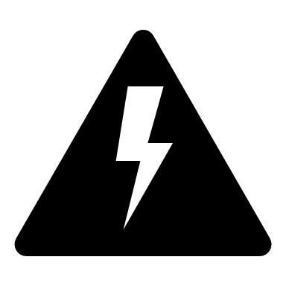

Please wait to submit other maintenance needs until further notice. Thank you for your help keeping one another healthy and safe.
-Aeon Management

For more language translations, please call 612-670-7115
Para tener acceso a la traducción en otros idiomas, por favor contactar 612-670-7115
Wixxi turjumaad dheeraad ah fadlan kala xirriir 612-670-7115
Hiikaa afaanota adda addaaf, maaloo 612-670-7115 quunnama'a
Muaj ntau hom lus xav muab txhais, thov hu 612-670-7115
Для переводов на другие языки, звоните на 612-670-7115
अधिक भाषा अनुवाद के लिए, कृपया कॉल करें 612-670-7115

